CF/NYH/IRM/RAM/1998-215
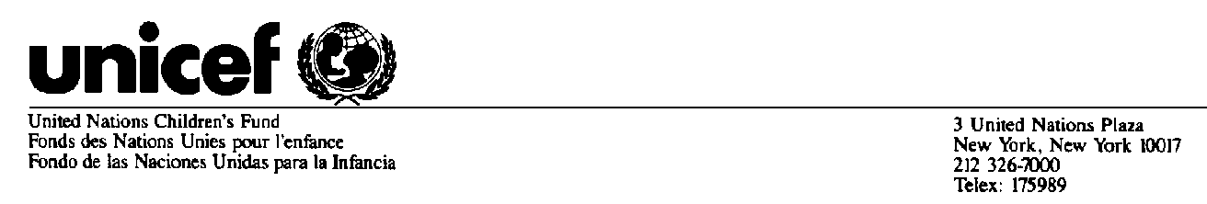
CF/NYH/OSEB/HST/1998-014
16 April 1998
Mr. Charles Egger
Rte de Gimel, 6
Mont S. Rolle 1185 VD
Switzerland

Dear Mr. Egger:

Ed Lannert alerted us that you were interested in some of the Historical Interviews. Please see the two lists attached:

ANNEX A: Interviews conducted by J. Charnow and Dan Jacobs of Charles Egger. Copies of each of these interviews are enclosed.

ANNEX B Other interviews where you are mentioned, copies are available.

If it would be of interest to you we could also provide a list of all the other interviews recorded as part of History interview series.

Please also note that the interview descriptions only contain as many keywords as would fit in the database field.

Let us know if we can be of further assistance. If you have any more recent articles, interviews or thoughts on you time with UNICEF we would be pleased to also register them with the History records.

If you should like to request any of these interviews, you can contact me by FAX, Phone or E-mail address below.

Sincerely,

Adhiratha Kevin Keefe
Records and Archive Management
3 UN Plaza, H-3F
New York, N.Y. 10017

FAX: 212-326-7790 Phone: 212-326-7667
E-mail: akeefe@unicef.org

