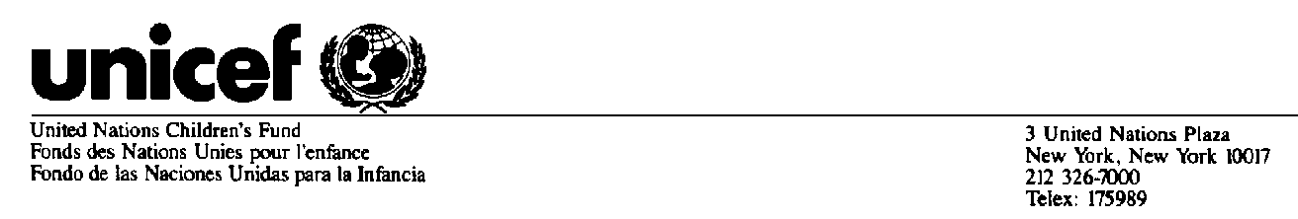
Believed to be the best available version at time of issuance

Commission on the Status of Women, 44th Session
And
Commission on the Status of Women acting as the Preparatory Committee for the Special Session of the UN General Assembly entitled "Women 2000: gender equality, development and peace for the twenty-first century"

Statement by Carol Bellamy
Executive Director
UNICEF

28 February 2000

Madame Chairperson, Distinguished delegates, Ladies and Gentlemen,

It is a pleasure to be here today to address the Commission on the Status of Women during this important session, when it will also act as preparatory committee for the Special Session of the General Assembly to take place in June. UNICEF had the privilege of participating in the preparatory regional conferences organized by the Regional Commissions in 1999 and earlier this year.

We have assembled here to review progress made in implementing the Beijing Platform for Action and decide on what new actions must be taken to achieve its goals. We must be honest in our appraisal of why the pace of implementation has been slow and in accounting for the gaps in our actions. Let us be open and frank in assessing what has worked and what has not and be grounded in the conviction that the equal rights of women and girls is an indispensable foundation for full development.

Madame Chairperson,

Since the Beijing Conference, there have been some gains for women and girls, but the reality is that millions of women still live in poverty, 600,000 women still die annually during pregnancy, 600 million cannot read or write and of the 100 million children out of school, two thirds are girls. Women and girls are the most affected during situations of armed conflict and by the HIV/AIDS catastrophe, many of them victims of violence and abuse. Millions of girls work in their own homes and in the homes of others, in factories and in bars, facing the risks of physical and sexual abuse by their employers. Many are trafficked across borders, often to be sexually exploited. Alarming new statistics show that, globally, at least one in three women and girls worldwide has been beaten or sexually abused in her lifetime. We also know that a key element in the expansion of the HIV-AIDS pandemic is the fact that women and girls do not have power to successfully negotiate their protection in the face of male power.

This must change. For girls and women, growing up and being equal is no longer a dream but is within reach. The world has the framework for global action. Human rights instruments and the international agreements reached at World Conferences provide the vision and inspiration for action. The missing ingredient is political commitment on a global scale – and resources and actions to match.

Distinguished delegates,

UNICEF identified three priority areas for implementation of the Beijing Platform for Action: girls' education, the health of girls and women, including adolescents, and children's and women's human rights. Its approach to follow-up of World Conferences has been through support to integrated and coordinated implementation in its country programmes of cooperation. I would like to share with you some of our experiences and the key lessons learnt.

First, the understanding that no real change will take place unless there is commitment at the highest level to the realisation of equal rights for women and girls and that human rights is the only effective framework for ensuring the full contribution of women to development efforts. The basis lies in human rights instruments such as the Convention on the Rights of the Child (CRC) and the Convention on the Elimination of Discrimination Against Women (CEDAW). We now have almost universal ratification of the CRC, but with about 27 countries that have yet to ratify CEDAW, its universal ratification will take more than a decade at the current rate of about two ratifications per year. And of those countries that have ratified CRC and CEDAW, too many have entered reservations that come in the way of removing discrimination and breaking barriers of social, economic and political structures. Even where countries have ratified these human rights instruments, the challenge of translating these commitments and guarantees into practical actions that make a difference in the daily lives of women and children, remains.

Second, expansion of girls' education is the key to fulfilling the rights of girls and women. In addressing this right, UNICEF has been working with others to go beyond improving access to schools to remove underlying structural causes of the gender inequality and the systematic discrimination faced by women and girls. ‘Girl-friendly’ schools and life-skills education, which builds the self-esteem of girls and their capacity to protect themselves against such common risks as violence, sexual abuse and exploitation, as well as the risks of early parenting, which often create circumstances that deprive girls of their right to education. At the same time, education for boys must specifically address the unlearning of negative behaviour patterns while promoting positive new behaviours based on tolerance and equality.

Between now and the Special Session, the World Education Forum, which will take place in Dakar, Senegal, in April, will adopt a new Framework for Action, based on the results of what has been the biggest review of education in history. This will provide valuable inputs to the review of progress made in girls' and women's education during the Special Session in June.

Third, strong partnerships among governments, civil society and United Nations agencies are becoming increasingly important. Promoting organised action by women's groups and communities is pivotal to change. The traditionally influential agents of change such as religious leaders, village elders, schoolteachers, and midwives, have already begun to play an important role in this process. At the same time, new and innovative ways are being tested to bring in the involvement of men and boys as partners at community levels for combating violence against women and ending discriminatory practices, such as female genital mutilation. We need to examine and learn from such experiences.

We recognize the sustained efforts of women's NGOs at national and international levels. I am glad to see many of them in the room today. In an environment where women continue to remain outside of the decision-making spheres and processes, NGOs have been instrumental in influencing policies and programmes for advancing women's rights. NGOs have been and will continue to be crucial partners in this review process. In advancing action for the achievement of the rights of women and girls, important progress has been made in building cooperation between women's rights and child rights groups to strengthen actions for gender equality from the earliest years and throughout the life cycle. We have an opportunity here to strengthen partnerships and put forward new strategies for joint action.

Madame Chairperson,

The preparation processes for the Special Session in June and for the Special Session that will be held in September 2001 to review progress made in implementing the goals of the World Summit for Children, provide excellent opportunities for renewing commitments, leveraging resources and fulfilling the rights of women and girls throughout the life cycle. The challenge lies in making these processes collaborative, participatory and forward-looking for the full realisation of international commitments to equality, development and peace.

