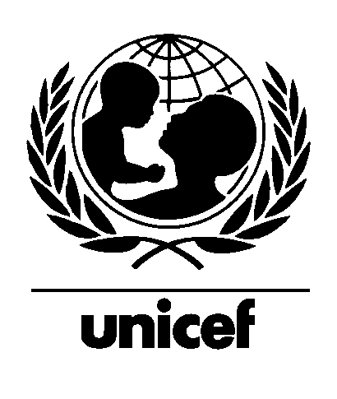

Sudan

Annual Report on Country Situation

1993

September 1993 For Internal Use Only
(Not for Quotation)

Ms. Audrey Hepburn during her visit to Muglad, Sudan in 1989. The Muglad camp, in the transitional zone, provided services to displaced people from the southern states fleeing the civil war. The Audrey Hepburn Memorial Fund is presently considering assistance to Sudanese children.

Table of Contents

Part I: Country Situation and Trends Towards the 1990s Goals 1

Part II:World Summit Follow-up, Convention on Child Rights and National Plan of Action 5
Major Developments in Advocacy for World Summit Follow-up 5
Current Status of the Convention 5
Preparation/Review/Refinement and Implementation of the National Programme of Action 5
Monitoring the 1990s Goals 6
Mid-decade Goals 6

Part III: Issues of Particular Concern to the UNICEF Executive Board 8
Multi-donor Evaluation 8
Family Planning 8
Use of Global Funds 9
Basic Education 10
Operation Lifeline Sudan 11
National Capacity Building 14
External Relations, Advocacy and Information 14
Staff Training 15

Part I: Country Situation and Trends Towards the 1990s Goals
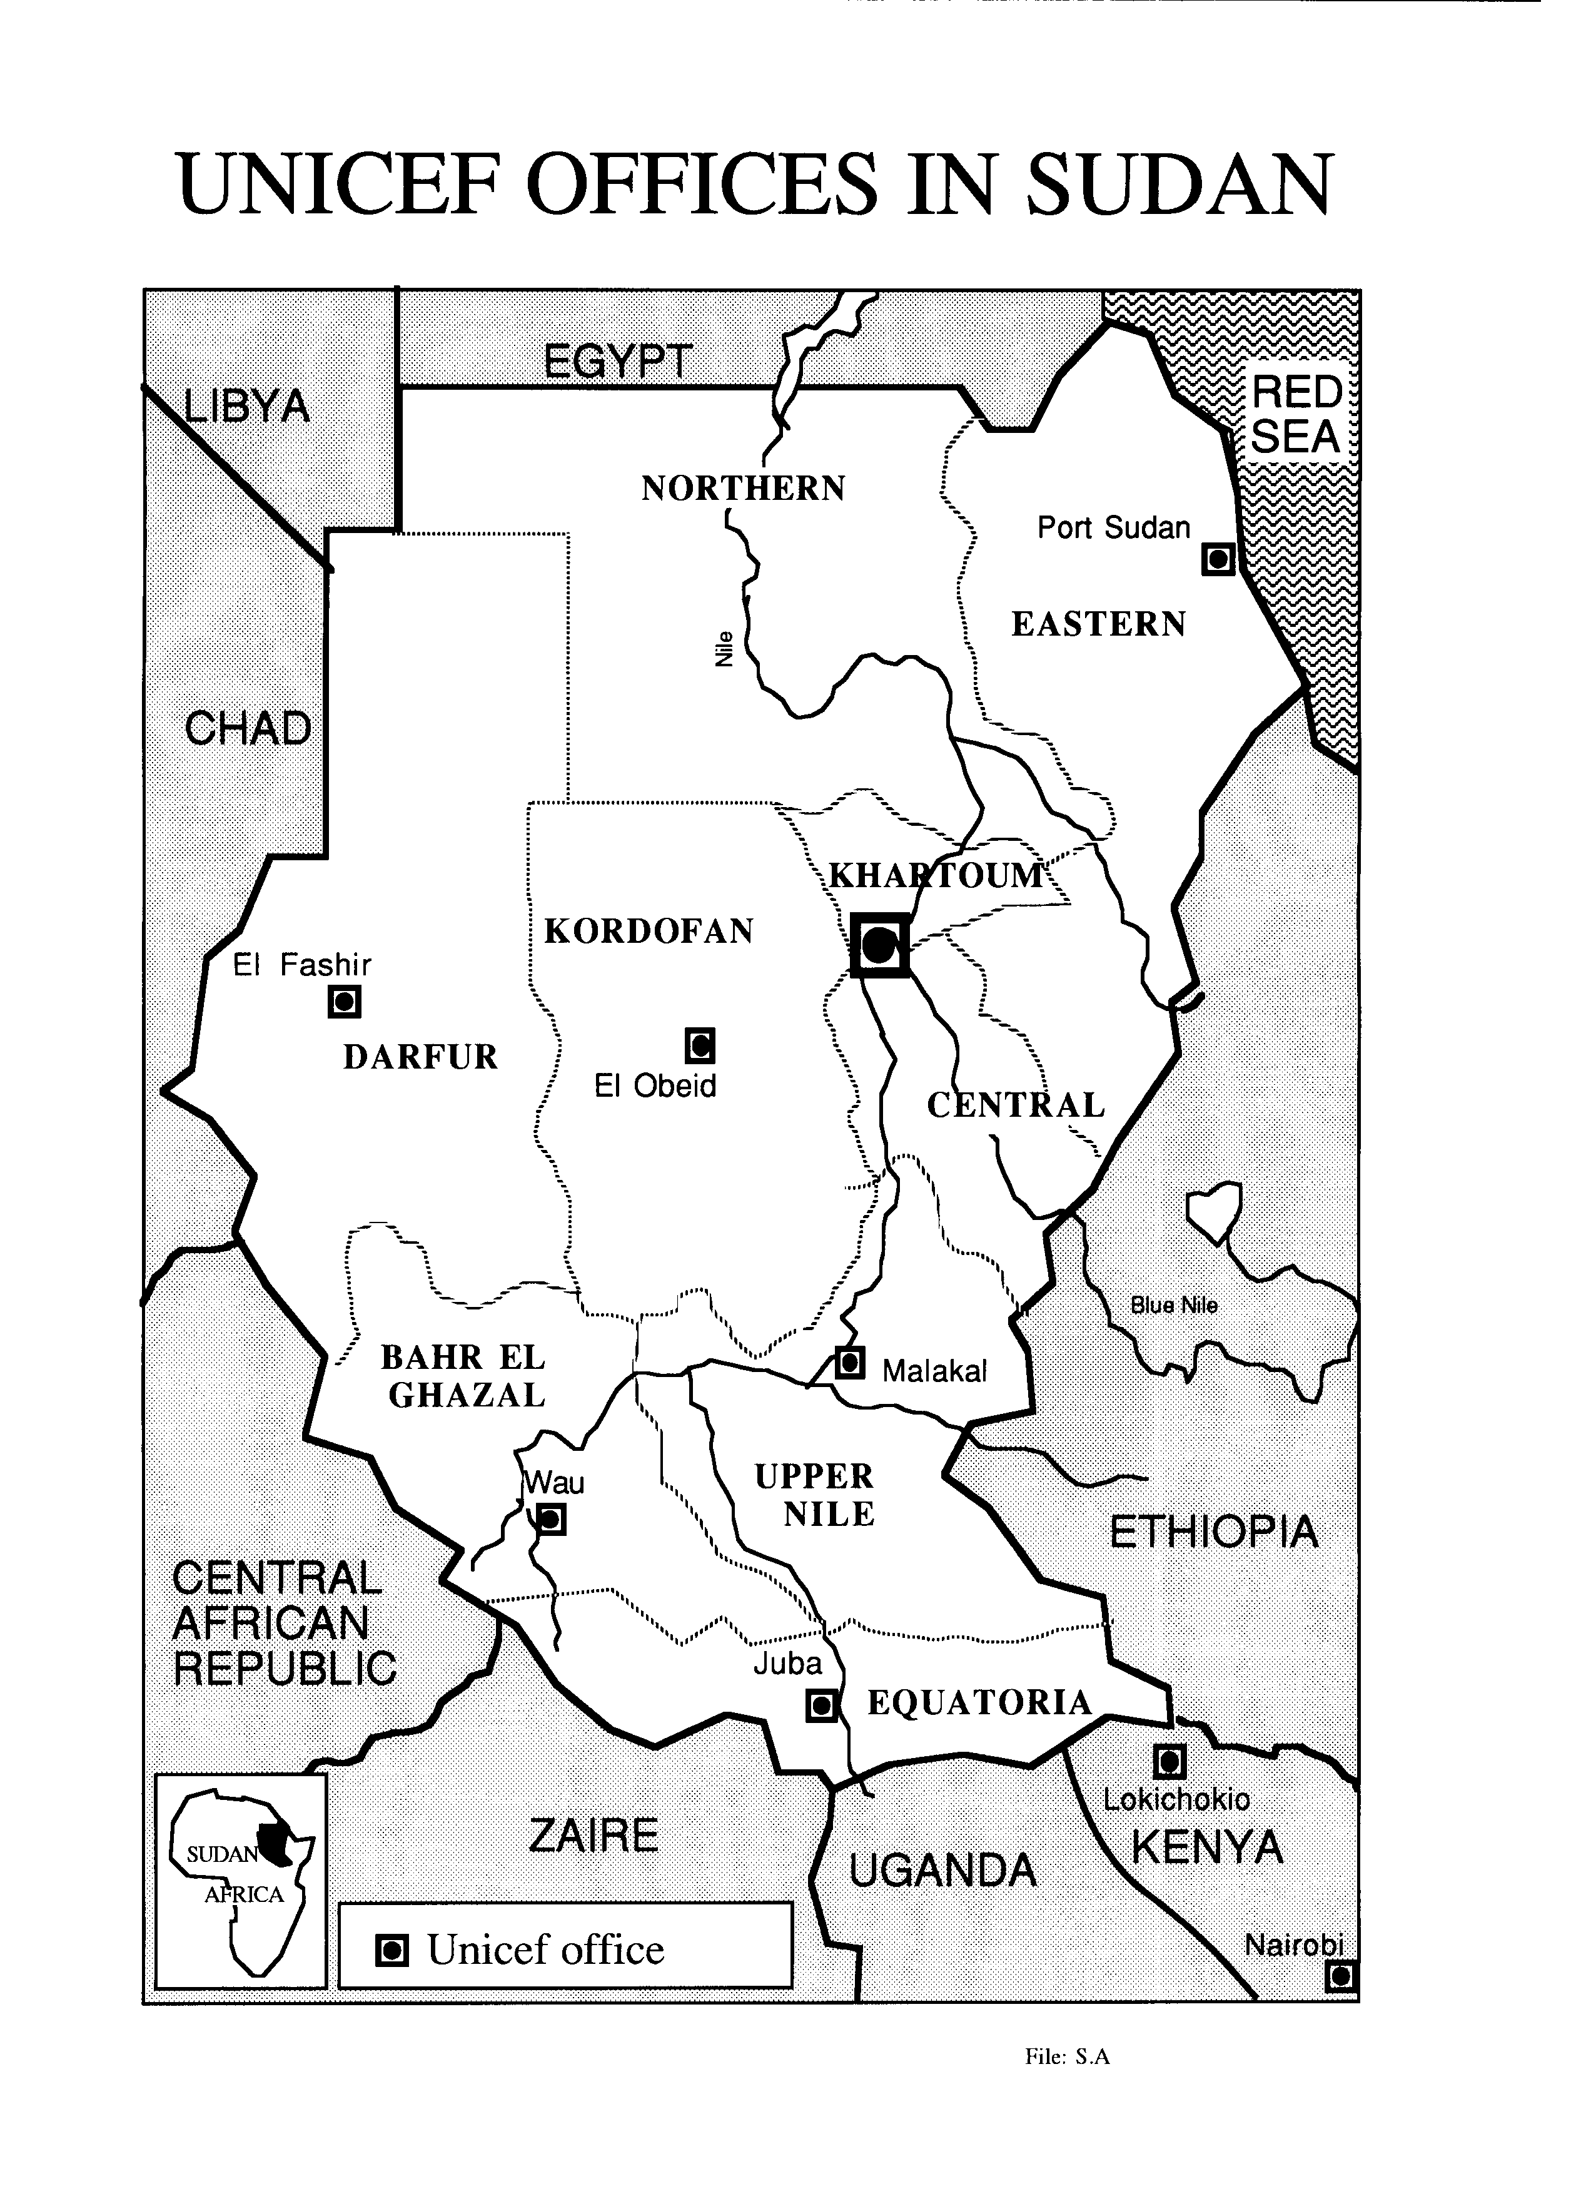

Political and Socio-economic Developments Affecting Children

Political Developments

The ten year old civil conflict continued during 1993, as did the inter-factional fighting within the SPLA. Despite the peace talks held in May 1993 and ceasefire agreements between GOS/SPLM and between the SPLA factions, the conflict intensified, especially in August and September, with a Government of Sudan (GOS) offensive in Equatoria in September. Of the estimated seven million people of the Sudan affected by the ongoing emergency, four million reside in the south; more than one third are children. Of them, approximately 1.5 million people were planned to be accessed from Nairobi for assistance and 2.5 million from Khartoum.

Relations with donor countries further deteriorated with the US declaration of Sudan as a nation supporting international terrorism. With donors continuing their freeze on development assistance to Sudan, receipts against supplementary funding for programmes for children remained very modest. Meanwhile, discussions with Egypt continued on the Halaib border issue. A mission from the UN Commission for Human Rights visited Sudan in September 1993 to review the situation in both government and SPLA held areas.

The Command Council of the Revolution for National Salvation (RCC) consolidated its position and a Cabinet reshuffle was undertaken in July/August 1993. The Ministry of Social Welfare was abolished with the establishment of the Ministry of Social Planning, leading to a break in continuity in counterpart agencies for the CEDC and WID programmes. A Minister for the Bureau of Federal Rule was appointed to strengthen decentralization and improve coordination between the central and state Governments; a move that fitted in with the UNICEF efforts at developing sub-national capacity to plan and coordinate state level programme initiatives in support of the decade goals. In addition, a new Ministry for Peace and Reconstruction was established with a mandate to oversee normalization of life in the south.

Following the 1992 launch of the ten year Comprehensive National Strategy incorporating strategies for child survival and women development, the Transitional National Assembly passed a three year Development Plan for the period 1993-95.

The Fourth National Population and Housing Census led to somewhat downward estimate of a total population of 25 million. Enumeration is reported to have been completed in all parts of the country with the exception of 11 provinces. Further analyses of census data are expected to throw light on age/sex composition and socio-economic characteristics of the population.

Economic Situation

Sudan has experienced mixed fortunes on the economic front. The country has reported a growth of over 13% in GDP for the fiscal year 1992/93 as compared to 11.3% in 1991/92. International estimates, however, are more modest: 7.6% in 1992, 4.3% in 1993 and a projection of 5.0% for 1994. This growth is primarily due to good harvests during the period, a consolidation and strengthening of the agricultural sector and low start off point in 1990.

On the other hand, continued inflation and a sharp fall in the real value of the Sudanese Pound aggravated the overall economic situation and caused hardship to the common citizen. Government reports indicate that the inflation rate rose to about 150% in the latter part of 1992, peaking in December, and declining to 80% in the first half of 1993. International forecasts indicate that inflation in 1993 may reach 115% as opposed to the hopes of the GOS to confine it to 45%. The impact of these trends was quite visible in the prices of basic commodities including bread, meat, chicken, fuel and transportation costs.

The exchange rate between the Sudanese Pound and the US $ has depreciated from LS 133.65 to the US dollar in January 1993 to Ls 163.5 in September. The rate in the parallel market was as high as Ls 270 - 280 in August/September.

The annual budget for 1993/94 amounts to Ls 233 billion (an increase of Ls 77 billion over 1992-93). A budget deficit of Ls 36 billion is projected for 1993/94 as compared to Ls 34 billion in 1992/93. However, given the declining exchange rate, the consequent increases in import bills and the low level of exports, the actual budget deficit may exceed the forecast - a trend that is likely to continue. This could entail difficulties of mobilizing counterpart funds for the country programme.

At the end of 1992, Sudan's external debt was estimated at nearly US $ 16 billion. Sudan's ability to service her external debt is declining with only US $ 23 million paid in 1991 and US $ 22 million in 1992 against an estimated US $ 1.2 billion due in 1991.

External assistance is expected to decline to 27% of the total budget. In this context, debt conversion assumes even greater priority as a means of raising critically needed resources for human development. During 1992, a UNICEF facilitated agreement between the GOS and Royal Bank of Canada released the equivalent of over one million US dollars in local currency for meeting programme expenditures.

Accurate data on public investment and external assistance to activities connected with the decade/intermediate goals (20/20 vision) is not readily available as it entails a more detailed sub-sectoral and programme/project-wise analysis of allocations and expenditure. This will be investigated as part of the ongoing Mid Term Review and Country Programming Process. However, in the Three Year Programme (1993/94 - 95/96), an allocation of £s.284,863 million (13.9% of total) has been proposed for the social development sector, with an additional £s. 92,222 million (4.5%) for water and sanitation, including sewage. The GOS does not envisage contributing more than twenty per cent of this investment with the balance expected to be generated by the private/non profit sector. In real terms, the investment is likely to be modest, given the depreciation of the local currency and the somewhat unrealistic expectations from the private/non-profit sector. This has implications for the achievement and sustainability of the intermediate/decade goals.

As a result of the spending cuts, the actual expenditure on the social service sector during 1992/93 was limited to approximately 60% of the budget allocation. To minimize the impact of the hyper-inflationary trends on the cost of living, the budget for 1993/94 apportions over 50% of the total for the social service sector to subsidies and compensations in various forms: wages, pension, social security benefits, donations to families most in need, subsidies on petrol, bread and other such services.

Among the other activities of the social service sector, the budget gives priority to projects in education, health and water supply with the aim of facilitating progress towards the universalization of basic education, primary health care and access to safe drinking water by the end of the decade.

Major Emergencies

For more than a decade now, millions of Sudanese remain trapped in civil conflict. In both rebel held areas and government controlled towns in the south of the country, civilian populations are severely affected by the lack of food, safe water, health and education services. In the transitional zone, between north and south, some 150,000 people live in special "peace camps" located in southern Kordofan and Darfur. In Khartoum, the large displaced population continued a precarious existence, albeit some settlements saw an improvement of services supported by UN and INGOs.

The Upper Nile state was especially hard hit by the ongoing conflict with armed attacks at Kongor, Ayod, Yuai, Bor and Watt. The fighting seriously disrupted emergency assistance to about 45,000 people. The insecurity also resulted in new population movements and an increase in the number of displaced persons: about 25,000 people are estimated to have moved towards Malakal, Canal, Obel and Nagdiar from other locations in Upper Nile; the influx of displaced persons from Bahr El Ghazal to southern Kordofan continued, with the daily arrivals to Meiram and Abyei displaced camps averaging 150 and 50 respectively. Over 2,750 persons were reported to have moved to Wau from Tonj and Gogrial in August. Darfur continued to receive new arrivals from the south, with some 27,000 new arrivals reported in Leit and 5,000 in El Fasher.

A joint GOS/UN mission to the Central state was undertaken in August 1993 to assess the extent of damage done by floods. Camps or settlements of unregistered labourers who had migrated into the state from war/drought affected areas were especially affected and the health of over 10,000 people was estimated to be at risk. Interventions recommended include supporting local capacity to prevent and tackle outbreaks of water borne diseases and malaria. UNICEF has supplied 2 MTS of blankets and 1 MT of essential drugs as a first response to the need for relief.

The intensification of the civil conflict has resulted in increased risks to the security of UNICEF staff, problems of access for delivery of relief supplies and for monitoring visits to displaced camps and difficult relations between the GOS and donors. Maintaining the pace of implementation of emergency activities in this environment has implied an investment of increased staff time and resources at all levels. This has had a concomitant impact on the advocacy and programme follow-up of the regular programme especially in relation to the achievement of the intermediate and decade goals.

Trends in Food Policy, Production and Distribution

The continued priority accorded to agricultural production and a year of good harvests resulted in the production of 133 % of the country's domestic requirement of sorghum and 97% of the requirement of wheat in 1992. As a consequence, the GOS decided to cover the total emergency cereal requirement of the country for 1993 and to contribute 153,000 MTS of sorghum. About half of the contribution has been handed to WFP for distribution.

The increase in food production was not matched with improvements in access to food, thus food security at the household level remains a concern. Quarterly nutrition surveys conducted in different parts of the country in 1992 and 1993 reflect acute malnutrition rates in children under 5 years of age (<80% WFH) ranging from 8 to 18.7% in the northern part of the Sudan. Malnutrition rates in the three southern states ranged from 15% to as high as 56.1% in Malakal (Upper Nile) and over 80% in the Triple A area. The six displaced camps in Kordofan reported a noteworthy reduction of malnutrition among children under five years from 40% in April 1993 to 28% in September 1993. In contrast, in Juba (Equatoria), where logistical constraints and security situation did not permit such timely and regular interventions by WFP and UNICEF, the nutritional status deteriorated in view of the heavy dependance on external assistance for food and supplementary food (UNIMIX) supplies.

Locust infestation in June-August 1993 was reported to have been extensive, especially in the states of Kordofan and Darfur threatening agricultural output. The total area affected is estimated at some 185,000 hectares. Control operations are in progress and thus far, about 16,500 hectares have been brought under control for swarms and hoppers and about 2,500 hectares for tree locusts. A crop assessment mission by FAO/WFP is scheduled for October this year.
Part II:World Summit Follow-up, Convention on Child Rights and National Plan of Action

Major Developments in Advocacy for World Summit Follow-up

Sudan was one of the first countries to develop an NPA in quick succession to the World Summit. The National Council for Child Welfare (NCCW), established in 1992 and chaired by the President, is strengthening its capacity to undertake key advocacy and monitoring functions in relation to the NPA. The NCCW promoted child related themes in the government and media advancing the UN Convention on the Rights of the Child; conducted a national level training workshop on monitoring and evaluation of the NPA; and organized a national forum on the Dakar Declaration and a joint review meeting on the NPA.

The NCCW has moved to establish a State Council for Child Welfare in the Central state and has initiated the process in five other states (Khartoum, Eastern, Equatoria, Kordofan and Darfur).

Current Status of the Convention

Following a comprehensive workshop on Child Rights, Sudan ratified the Convention on the Rights of the Child (CRC) on 8 August 1990. NCCW has been given the responsibility for its monitoring. The NCCW organized a workshop in May 1993 in which it was recommended that all laws in Sudan relating to children be compiled, reviewed and, where necessary, amended to conform to the provisions of the Convention.

Specific issues of concern in Sudan are the effects of war on children, unaccompanied minors and children displaced by the emergencies. Interventions for their protection and rehabilitation are highlighted under the section on Emergencies.

Preparation/Review/Refinement and Implementation of the National Programme of Action

Building on the move towards federalization, UNICEF is supporting the preparation of state specific situation analyses and Plans of Action in the six northern states. Interdisciplinary teams have been formed comprising members from the Ministry of Planning at the central level, the NCCW, the concerned state Government and UNICEF. State level orientation workshops have been conducted in five of the six states and have served as valuable fora for advocacy and follow up with high level policy makers and administrators, particularly governors (Walis), their deputies and the state Council of Ministers. The State Programmes of Action (SPA) are expected to be ready by early 1994. However, the financing of SPAs may encounter difficulties, especially if expectations of greater assistance are created in the process of the preparation of the SPAs.

The UNICEF office in Sudan has advocated the Child Friendly Village (CFV) strategy as a means of making the NPA operational at the community level. The CFV strategy includes a set of operational indicators and action points derived from the NPA goals for implementation by the communities themselves. The strategy lays emphasis on empowering communities to understand, adopt and act on these elements and promote inter-sectoral convergence. This initiative has been launched in 20 villages in Kordofan state to be expanded to 50 villages by year end. State Officials have endorsed the CFV strategy and urged NGOs, Govt Depts. and other agencies to work within its framework. The State Government has also allocated a sum of Ls one million for the initiation of community managed revolving funds for essential drugs and medicines in the CFV villages.

Inter-agency collaboration between UNDP and UNICEF is enabling the convergence of economic empowerment supported by the Area Development Services project of the UNDP with the strengthening of social services envisaged in the CFV strategy. These initiatives will be documented and assessed in 1994 for wider diffusion and adoption.

Monitoring the 1990s Goals

The NPA vests the responsibility for monitoring progress against the CSD goals with the NCCW with the technical support of the National Population Committee (NPC) in the collection and analysis of data. The Ministry for Economic Planning and Investment has the responsibility for monitoring resource allocation while monitoring of sectoral programmes and projects is to be done by the sectoral ministries.

UNICEF supported capacity building among the various agencies involved, including sponsorship of two participants from the MEPI and the Faculty of Economics of the Khartoum University to a cost analysis workshop held in Namibia in July '93 and orientation of the faculty of the NPC and over 20 other representatives from various Ministries and government departments to DEEDS with assistance for its installation and use.

In addition, EPI track continues to provide regular information on immunization coverage and quarterly nutrition surveys supported by UNICEF and undertaken by NGOs and the Ministry of Health at the central and state levels, provide regular feedback on nutrition status of preschool children. The first phase of an active case search on guineaworm has been completed in the five endemic states of Bahr El Ghazal, Kordofan, Darfur, Central and Khartoum. A total of 180 endemic villages have been identified with 2,447 active cases. The second phase of the search in the other four states of Equatoria, Upper Nile, Eastern and Northern is scheduled to be completed by early 1994. A nationwide survey on enrolment and education status of children with an emphasis on girls' education, a rapid PHC review and a focussed CDD review have been completed and final reports are being compiled. In addition, the results of the recently conducted PAP child survey are expected by the end of the year and will be useful in assessing interim progress. An update of the situation analysis of children and women at the national level has been commissioned and will be completed by the NPC by December 1993. This activity, along with the state situation analyses are expected to yield data for monitoring of the goals while at the same time building capacity in local agencies for evaluation and monitoring.

However, paucity of reliable data and lack of adequate systems for information gathering, retrieval and analysis in support of monitoring continue to be a concern in the Sudan.

Mid-decade Goals

A strategy and workplan has been developed within UNICEF Sudan for the achievement of the intermediate goals for 1995. The document assesses the current status against each of the intermediate goals and identifies key strategies and activities required to promote their accomplishment. A three year office workplan in support of the implementation of the workplan has also been attempted. However, these need to be supplemented with efforts to mobilize government counterparts. It is expected that the Mid Term Review with the GOS scheduled for October 1993, as well as the update of the situation analysis and the development of SPAs, will provide opportunities for this.
Part III: Issues of Particular Concern to the UNICEF Executive Board

Multi-donor Evaluation

The report of the multi donor evaluation of UNICEF provides useful insights for analysis of the present cooperation and for the identification of strategies for the future. The following specific actions have been initiated

•the update of the situation analysis of children and women scheduled to be completed by December 1993 will include a focus on the existing status vis-a vis capacity building and empowerment, so as to enable the identification of an appropriate mix of strategies for the next cycle of cooperation;

•support to the preparation of state situation analyses and programmes of action aims at building capacity at the sub-national level to plan, programme and monitor interventions for the development of women and children;

•the Child Friendly Village initiative reflects a similar effort at empowerment and capacity building of local communities, as does the collaboration with UNDP on the ADS projects;

•the key recommendations of the evaluation have been included as one of the three reference points for the Mid Term Review scheduled for October 1993, the other two being the Master Plan of Operations (MPO) and the Strategy and Workplan for the Intermediate Goals;

•the recently completed rapid PHC review includes the three broad strategic concerns suggested in the multi-donor evaluation;

•a review of the emergency programme is an integral part of the Mid Term Review and the country programming process: this will lead to a more explicit integration of relief activities in the country programme of cooperation as recommended by the evaluation.

Family Planning

Sudan was one of the ten countries included in the case study submitted to the Executive Board in 1992 on UNICEF/UNFPA collaboration. Family Planning was one of the priority programme areas in which collaboration between the two agencies and Government was given emphasis. However, a joint Plan of Action is yet to emerge.

UNICEF is cooperating with the Sudan Family Planning Association under the auspices of the Ministry of Health to implement the Maternal and Child Health and Family Planning component of the current Master Plan of Operation 1991-95. This plan is designed to achieve a target of one trained Birth Attendant per 2000 population by 1995. The first step taken in 1992/93 was to update the curriculum of all nursing and midwifery trainees to include family planning modules. The job description of all cadres of MCH personnel were also updated to include family planning responsibilities. To date 10 master trainers, 40 trainers and 1,640 TBAs have been trained in the new curriculum in Darfur, Kordofan, Khartoum and Bahr El Ghazal.

UNICEF has also initiated the inclusion of child spacing messages into the Sudanese version of Facts For Life. In addition, the National Breast Feeding Committee, established in 1992, comprises a cross-section of experts and practitioners in health and communication fields who will contribute an inter- disciplinary perspective to national family planning activities.

Use of Global Funds

Global funds have been allocated for three major programme initiatives, viz, preparatory activities for the Bamako Initiative; conduct of a nationwide active case search for guineaworm incidence in Sudan and its control and eradication; and advocacy, mobilization and sensitization activities for the eradication of harmful traditional practices. The last two have been accepted as goals in the NPA and all three activities are fully integrated in the ongoing programme of cooperation.

Bamako Initiative

Funds allocated have been used to finalize the action plan for pilot testing BI principles in three Health Areas; provide technical support to Federal Ministry of Health (FMOH) for the design of national policy framework and operational guidelines for strengthening PHC strengthening; conduct studies on financing and other issues at local and national levels; and prepare a comprehensive plan for replication and expansion.

BI is now fully integrated into the national PHC structure with a decree promulgated for setting up multi-sectoral Task Forces at Federal and state levels and a national coordinator appointed to oversee preparatory processes and future expansion.

The first pilot scheme was initiated in El Rahad Health Area in Kordofan in June '93 to test national prototypes. Training, drug provision and financial systems are in place; management teams have been established with communities playing a major role; prices have been set for both services and drugs, and monitoring mechanisms established in accordance with BI concepts and national policy.

A recent visit by the BIMU team, NYHQ, confirmed that the BI has taken off on strong foundation and with a good understanding of the concept by both health workers and the community. Based on this experience, two additional Health Areas will be operationalized during the last quarter of this year. The target is to gradually expand up to 12 Health Areas by end of 1994, subject to availability of funds.

Sudan Guineaworm Eradication Programme

The key achievement to date of the Sudan Guineaworm Eradication Programme (SGWEP) include:

•completion of the active case search in five endemic states (Bahr El Ghazal, Central, Kordofan, Darfur and Khartoum) covering over 11,000 villages which resulted in the identification of some 2,500 cases of guineaworm infestation in 180 endemic villages.

•training of over 1000 health workers including 18 state coordinators, 120 provincial coordinators and some 450 enumerators.

•start of intervention activities in the three most endemic areas--Elmazmoum, Boot and Gulli--where over 70% of the cases were found;

•initiation of an active case search in the remaining four states in July/August to complete the national picture.

•development of Plan of Action for Phase II comprising programme interventions and ongoing surveillance activities leading to eradication by the target year of 1995.

However, insecurity, inaccessibility and transport problems, especially in the South, where guineaworm is known to be highly endemic, are the most important factors constraining implementation of the programme and the eradication of the problem by 1995.

Eradication of Harmful Traditional Practices (HTP)

The eradication of harmful traditional practices has been accepted as a goal for the year 2000 in the NPA. UNICEF cooperates with GOS in advocacy, sensitization and mobilization activities in support of this goal.

An interdisciplinary National Steering Committee has been established comprising representatives from different Ministries, NGOs, women's groups and academic institutions to oversee the planning, implementation and monitoring of activities. The states of Kordofan and Darfur have been identified for special focus.

Traditional Birth Attendants and midwives are the main persons who actually conduct the operation of female genital mutilation(FGM). FGM represents a major source of income for them. Since February 1993, the Ministry of Health with UNICEF support has been conducting training and orientation of TBAs and Midwives on HTP. A study on this training effort is scheduled for November 1993 to assess the impact of the training programmes and opportunity costs to the TBAs and midwives of discouraging such practices. The study is expected to yield insights on other interventions that would be required to change practices at the community level.

Basic Education

The ten year strategy adopted by GOS includes education for all as a goal for human resource development.

Some of the strategies adopted by GOS for universalization of basic education are

•ensuring, by 1995, a place in school for all children who apply for admission;

•utilization of khalwas and literacy classes as a non-formal system to cater to the needs of out of school children, especially girls, with appropriate mechanisms to improve the quality of education and promote equivalence between the formal and non-formal systems;

•reform and restructuring of teacher training.

UNICEF has cooperated in planning and conducting a national cluster survey on basic education with a focus on girls education; implementation of an emergency education project which benefits about 270,000 children in displaced camps and war affected areas in eight states of the country; formulation of state level plans of action for EFA; and completion of an assessment of the present situation on early childhood care and education as the basis for formulation of policies and strategies for intervention. In addition, a proposal for augmenting the capacity of the Ministry of Education to produce textbooks is awaiting approval by the Audrey Hepburn Memorial Fund.

The campaign to eradicate illiteracy initiated in Darfur state has been expanded to Kordofan and Eastern state. Activities in Darfur have been accelerated and for the first time in the history of Sudan, one province in the state is to be declared fully literate in September 1993. UNICEF has cooperated in this initiative by providing support for the incorporation of Facts for Life in the content of the literacy classes and for key evaluation studies.

External assistance for EFA has declined over the years, a trend that has been aggravated in recent years. However, the GOS is in the process of finalizing a project with UNDP on the education of youth through literacy classes. UNESCO and its sister agencies for the Arab and Islamic countries such as ISESCO and ALESCO support the development of Khalwas. UNESCO also assists the Bakht El Ruda Curriculum Development Centre, while details of cooperation with WFP are being finalized for a Food for Work Programme for construction of classrooms and sanitation facilities under the emergency education project.

Operation Lifeline Sudan

UNICEF emergency activities continued within the framework of OLS principles and were coordinated by Khartoum and Nairobi offices. UNICEF, jointly with other UN agencies and GOS and SPLM counterparts, undertook needs assessments of populations, especially children and women, displaced by the civil war and affected by natural calamities. A revised instrument for needs assessment including survey component has been prepared in consultation with other UN agencies and is being field tested.

While the population in need of food assistance was estimated at about 1.1 million, those in need of non-food assistance in the form of health, nutrition, water supply and sanitation, education, relief and shelter were estimated at 7.6 million - over a third of them children. About 40 priority locations are planned to be accessed from Khartoum and 24 locations served from Nairobi.

In the 1993 SEPHA appeal, financial requirements of UNICEF for the provision of non-food services were estimated at US $ 40.773 million. As of 31 August 1993, pledges against the appeal totalled US $ 17.6 million (43.1%) and actual receipts amounted to US $ 14.73 million (36% of the

appeal). This was in addition to an allocation of US $ 5 million from UNICEF global emergency fund and a contribution in the pipeline of 15 solar powered vaccine refrigerators and 30 solar powered light units from the Norwegian government. An informal meeting to alert donors to the need for prioritizing and facilitating additional funds is scheduled for September 28 in Geneva.
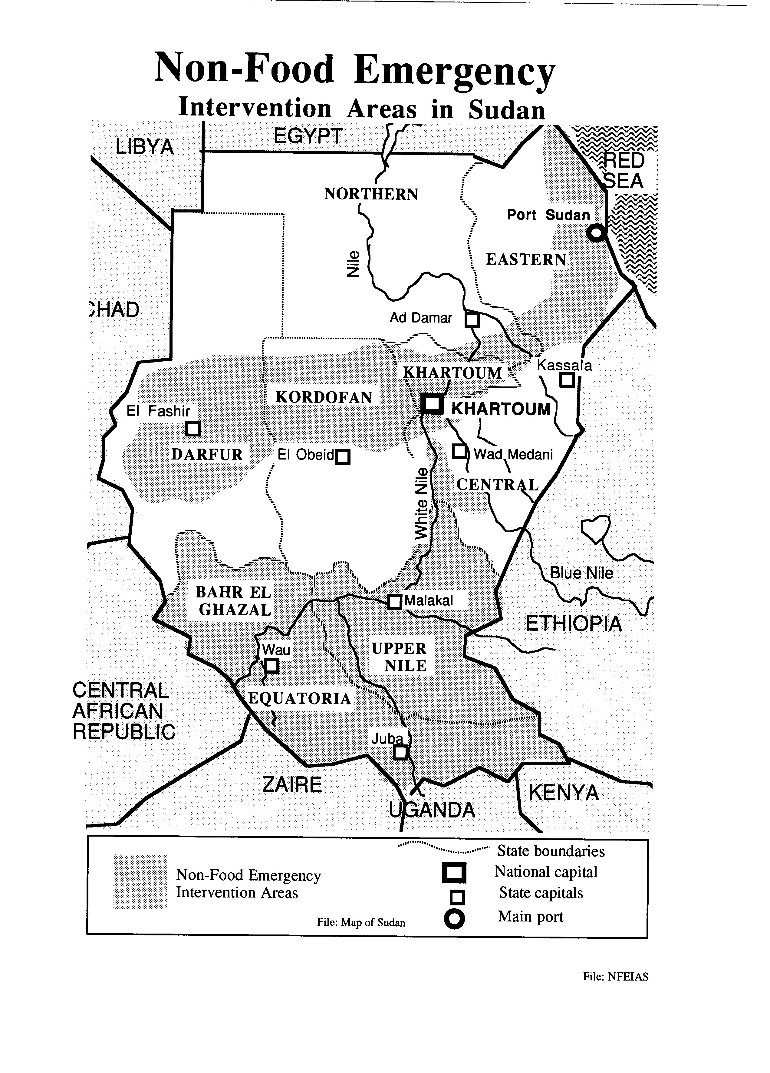

Relief activities have been sustained and expanded in an overall atmosphere of increasing constraints and fluctuating circumstances regarding donor community, INGOs and GOS.

The visit of the Under-Secretary General for Humanitarian Affairs, towards the end of 1992, paved the way for a UN/GOS/NGOs meeting in January 1993. Accordingly, a basic framework for the involvement of NGOs in relief activities was developed and the role of GOS in facilitating this was agreed upon. As a follow up, GOS has established the office of the Commissioner for Voluntary Agencies (COVA) to coordinate NGO efforts. However, the actual implementation of International NGO participation in relief and rehabilitation has been a slower process than anticipated. The visit also resulted in proximity talks in Nairobi between the three factions of the SPLM, GOS and the UN, with the presence of UNICEF and WFP. Chaired by the Department of Humanitarian Affairs, the meeting resulted in agreements on full access for OLS to all locations for assessment purposes; reopening of the rail corridor to Wau from the north and opening of the Nile corridor from Malakal to Juba and Malakal to Nasir; and facilitation by all parties to the conflict of access to civilian population in need.

Meanwhile, with the escalation of the conflict and the inter-factional fighting in the last few months, constraints on access and security problems have increased. A high level mission led by the Secretary General's Special Envoy for Humanitarian Affairs for Sudan reviewed the constraints with GOS in August 1993 with a view to enhancing opportunities for and cooperation among the concerned parties.

Emergency operations are integrated, to the extent feasible, within the country programme where all programme and operations units of the Khartoum Office handling both the emergency and the regular programme. In addition, emergency coordinators have been appointed in El Obeid, El Fasher, Juba in both Northern and Southern States and the sub-offices in Wau and Malakal have been strengthened. The Lokichokio Base Camp now caters for over 120 people each day and is a resource base for over 150 OLS staff in the field. Provided funds are available, OLS Nairobi plans to recruit an additional 7-8 UNVs to cater to the increase in demand for services.

The Nairobi office now runs two DC-3, one Twin Otter and one Caravan to deliver non-food assistance into southern Sudan. Together with non-food assistance, OLS Nairobi transports some 450 MTS by air each month. The Twin Otter operated by the Khartoum office had, until end August, logged over 700 flying hours, transported some 1500 passengers and delivered some 400 MTS of essential non-food supplies in addition to items supplied through WFP barge operations, and overland transportation.

Since lack of coordination and timely information hampered effective response to emergency situations, a number of steps have been initiated to strengthen planning, monitoring, documentation and reporting. A monthly reporting system from the field offices was established to track progress on the 100 Day Action Plan and help identify mid-course corrections and new needs. Since its inception, over 100 issues of the weekly Emergency Update have been produced and disseminated within UNICEF and among the UN agencies and donors. A monthly progress report on Emergency activities is compiled and distributed to all concerned and a comprehensive report on the 100 Day Action Plan is being finalized. A new action plan for the balance of the year is under preparation and further details on the services provided will be reflected in the Annual Programme Progress Report due in December 1993.

Emergency operations will continue as a major preoccupation in the coming years; a corresponding effect on the achievement of the intermediate and decade goals may be expected. Hence there is a need to integrate emergency relief and rehabilitation efforts, to the extent feasible, with the strategies for achievement of goals such as reaching the unreached so that both silent and local emergencies could be systematically addressed. This will be a major focus of the forthcoming Mid Term Review and the Country Programme Exercise.

National Capacity Building

UNICEF supported the participation of 25 key counterparts in 20 training and orientation programmes covering a wide range of issues such as girls education, social development of nomadic communities, child trauma, medical education, Vit A deficiency, ARI, CDD, nutrition, epidemiology, women's literacy and cost analysis of primary health care. In addition, UNICEF supported a study visit to the water supply programme in China.

Support to the preparation of state situation analysis and SPAs, and the active involvement of the NCCW and the NPC in the update of the sitan report at the national level reflect specific outcomes of a conscious strategy to use programming opportunities to the maximum for capacity building. This approach has also been followed in the sectoral programmes: for example, both the rapid PHC review and the focussed CDD review involved the collaboration and participation of GOS as well as WHO counterparts at all stages.

External Relations, Advocacy and Information

The main thrusts of these activities remained the same: addressing GOS to promote CSD action in favour of women and children and, at the same time, to advocate the need to continue emergency humanitarian operations, particularly in southern Sudan. In parallel, SCO focussed on mobilizing further donor support for emergency action and raising awareness of the urgent needs in the country.

Activities included weekly meetings with the Relief and Rehabilitation Commission, sister UN agencies, donors and NGOs, supported by a weekly Update. Donor representatives, CIDA staff, and UNICEF HQ/National Committee staff have visited field locations. A few international journalists were briefed on UNICEF action.

Launching of special reports (SOWCR, Progress of Nations, UNICEF Annual Report) and celebration of special events (DAC, World Breastfeeding Week, Arab Child Day, IDBC) have been used to highlight the situation of women and children. These events have taken innovative and colourful shapes including street theatre, competitions for children, and sporting activities. Participation has grown out to field locations, even in emergency stricken areas like Juba and Malakal. There is often a linkage to programme interventions (launching BI, Child Friendly Villages, new editions of the Sudanese version of FFL). As can be expected, national media remained reluctant to pick up the more critical aspects of the situation of women and children, notably in the case of the Progress of Nations report. To ensure effective dissemination, SCO has regularized and expanded its publication distribution system to reach out to key GOS, media, UN, donor and NGO audiences, and the early version of CDB distribution system was tried out. (The new version, under development at NYHQ, is awaited eagerly).

Having hit a low point at the time of the Gulf war, GOS relations with donors, especially the US, continued to deteriorate. The UN was often at the centre of contention, with repeated demonstrations, media attacks, and GOS protests on "violations" in the context of OLS southern sector and INGOs. Themes of human rights, the New World Order, economic blockade and the "double standard" of the international system became much more prominent in the national media.

Access by UN staff, visitors, and international media became increasingly difficult and sensitive. It is hoped that the situation will improve in the case of UN staff, following the recent visit of Ambassador Traxler.

More substantially, several structural aspects of the situation continue to shape the effectiveness of advocacy efforts. There are the difficulties of implementing a developmental programme that requires close cooperation with GOS and the tensions and staff time requirements, generated by emergency operations. It has been necessary to sensitize donors repeatedly on this delicate matter. While donor interest in funding development action has all but ceased, their response to emergency funding requirements remains limited.

Facts for Life expanded to a major initiative, despite the disappointment of lack of GOS financial inputs. Over 1,400 teachers, 40 religious leaders, 25 TV staff have been oriented on this initiative with a wide range of printed material supporting it.

Staff Training

Thirty two staff members benefitted from training on issues such as social mobilization and communication, CRC, management and operations, English language (for drivers), EDP and personnel management. Special efforts were made to streamline identification of training needs and selection of staff for training from Khartoum and the Sub-offices by setting up a local Training Committee.
INDEX

ADOLESCENTS AND ADULTS
WOMEN 1, 6, 8, 10, 11, 14
AGENCIES AND ORGANIZATIONS
INTERNATIONAL NGO 13
NGO 13, 14
AGENCY POLICIES
ADVOCACY 3, 5, 9, 10, 14, 15
AUXILIARY HEALTH WORKERS
HEALTH WORKERS 9, 10
TRADITIONAL BIRTH ATTENDANTS 10
BILATERAL AGENCIES
CIDA 14
BUILDINGS AND FACILITIES
HOUSING 1
WORKSHOPS 5
CHILD DEVELOPMENT
CHILDHOOD 11
EARLY CHILDHOOD 11
CHILDREN AND YOUTH WITH PROBLEMS
CEDC 1
COMMERCE
EXPORTS 2
COMMUNICATIONS
TRANSPORTATION 2, 13
CONCERTED PROGRAMMES
BAMAKO INITIATIVE 9
COOPERATION PROGRAMMES
SITUATION ANALYSIS 6-8, 14
SUPPLEMENTARY FUNDING 1
COOPERATION PROJECTS
PLAN OF OPERATIONS 8
PROJECTS 3, 6, 8
CULTURAL FACTORS
HISTORY 11
LANGUAGE 15
CURRICULUM
CURRICULUM 8, 9, 11
CURRICULUM DEVELOPMENT 11
DEFICIENCIES
MALNUTRITION 4
DEVELOPMENT
AREA DEVELOPMENT 6
SOCIAL DEVELOPMENT 2, 14
DEVELOPMENT STRATEGIES AND APPROACHES
CAPACITY BUILDING 6, 8, 14
DISASTERS
CIVIL WAR 2, 11
FLOODS 3
DISEASES - BROAD CONCEPTS
DISEASES 3
ECONOMIC ASPECTS
ECONOMIC PLANNING 6
ECONOMICS 6
ECONOMIC FACTORS
INCOME 10
EDUCATION SERVICES IN GENERAL
EDUCATION 3, 6, 10, 11, 14
FAMILY AND CHILD ASPECTS
CHILD WELFARE 5
FAMILY ASPECTS
CHILD HEALTH 8
FAMILY PLANNING 8, 9
MATERNAL AND CHILD HEALTH 8
FEEDING
BREASTFEEDING 14
FEEDING 9
FINANCE
COSTS 2, 10
FUNDING 1, 15
FOOD PRODUCTION
FOOD PRODUCTION 3
FORM TERMS FOR DOCUMENTS
REPORT 1, 8, 13, 14
FORMAL EDUCATION
BASIC EDUCATION 3, 10, 11
GROUPS
FAMILIES 2
HEALTH MANPOWER
MIDWIVES 10
HEALTH SCIENCES
EPIDEMIOLOGY 14
HEALTH, BROAD CONCEPTS
HEALTH 3, 6, 8-11, 14
PRIMARY HEALTH CARE 3, 14
HIGHER AND PROFESSIONAL EDUCATION
MEDICAL EDUCATION 14
INSTRUCTIONAL MATERIALS
TEXTBOOKS 11
INTERNATIONAL RELATIONS
CONVENTION 5
IRM TOPICS
EDP 15
MANAGEMENT
MANAGEMENT 9, 15
PERSONNEL MANAGEMENT 15
MEDICAL SUPPLIES
DRUGS 3, 6, 9
ESSENTIAL DRUGS 3, 6
NON-FORMAL EDUCATION
ILLITERACY 11
NUTRITION - BROAD CONCEPTS
NUTRITION 4, 6, 11, 14
PEOPLE DEFINED BY OCCUPATION
ADMINISTRATORS 5
EXPERTS 9
LEADERS 15
TEACHERS 15
TRAINERS 9
PHARMACEUTICALS
ESSENTIAL DRUGS 3, 6
POLICIES AND LEGISLATION
DECENTRALIZATION 1
POLICY GOALS
DEVELOPMENT 1, 2, 6-8, 10, 11, 14, 15
HUMAN RIGHTS 1, 15
PEACE 1, 3
WELFARE 1, 5
PREVENTION AND TREATMENT
IMMUNIZATION 6
IMMUNIZATION COVERAGE 6
REHABILITATION 5, 13, 14
PROBLEMS CONCERNING CHILDREN
ADOPTION 6
PROGRAMMES AND PROJECTS
EPI 6
RESOURCES AND SUPPLIES
SUPPLIES 3, 4, 13
RESPIRATORY DISEASES
ARI 14
RURAL PROCESSES
WHEAT 3
SANITATION
SANITATION 2, 11
SOCIAL POLICIES
LITERACY 10, 11, 14
SOCIAL MOBILIZATION 15
SOCIAL PLANNING 1
SOCIAL WELFARE 1
SOCIAL SERVICES
SOCIAL SERVICES 6
STATISTICS
INDICATORS 5
SURVEYS
NUTRITION SURVEYS 4, 6
TECHNICAL-VOCATIONAL EDUCATION
TRAINING 5, 9-11, 14, 15
TRAINING PROGRAMMES 10
THE YOUNG
CHILDREN 2, 1, 4-6, 8, 10, 11, 14
GIRLS 6, 10, 11, 14
PRESCHOOL CHILDREN 6
YOUTH 11
TROPICAL DISEASES
MALARIA 3
UN AGENCIES
FAO 4
UN 1, 3, 5, 11, 13-15
UNDP 6, 8, 11
UNESCO 11
UNFPA 8
WFP 3, 4, 11, 13
WHO 3, 9, 10, 14
UNICEF
UNICEF EXECUTIVE BOARD 8
WATER
DRINKING WATER 3
WATER 2, 3, 11, 14
WATER SUPPLY 3, 11, 14

