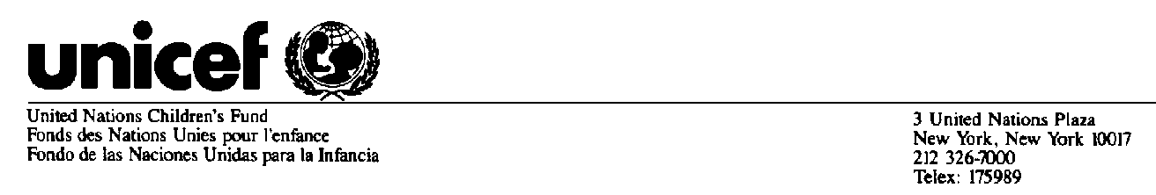
Believed to be the best available version at time of issuance

STATEMENT ATTRIBUTABLE TO CAROL BELLAMY, EXECUTIVE DIRECTOR OF THE UNITED NATIONS
CHILDREN'S FUND (UNICEF)

New York – 4 September 1998

Three members of the UNICEF family were among the passengers in the terrible accident involving a Swissair plane en route to Geneva on the night of 2 September. They were UNICEF staff member, Mr. Yves De Roussan; Ms. Ingrid Acevedo, a staff member of the US Committee for UNICEF, and a former UNICEF staff member, Mr. Pierce Gerety. In addition, a number of staff from sister agencies lost their lives.

Our hearts and prayers go out to the families and colleagues of all who were on the flight. UNICEF and the UN as a whole has suffered a grievous loss.

Mr. Yves De Roussan came to UNICEF in 1987 to serve in Brazil as Assistant Programme Officer. In July 1992 he became Project Officer in Antananarivo, Madagascar, and later served in a similar capacity in Luanda, Angola. In 1997 he became Regional Adviser to UNICEF for Central Europe, the Baltic and the states of the former Soviet Union. The focus of Mr. De Roussan's work was youth. He worked with adolescents who came into conflict with the law, who were abandoned by their families or who lived on the streets.

He approached his work from the point of view of protecting children. Mr. De Roussan was a native of Canada and is survived by his wife, Maria Aparecida Liete, his sons Eric and Taina; and his daughters Gaille and Maira.

Ingrid Acevedo came to the United States Committee for UNICEF from Bread for the World in 1995. She served first as Acting Director, and then as Director, of the National Committee's Public Relations. Her highly professional and committed work within and beyond UNICEF was widely praised, and her relationship with her colleagues was one of exceptional warmth. Under her leadership UNICEF received wide coverage in major media in and beyond the United States. She played a key role in the current revival of the Trick-or Treat for UNICEF campaign. She also served as the primary media liaison during the Olympic Games for Olympic Aid Atlanta. She will be greatly missed. She is survived by her mother, Dinora Acevedo.

-more-
-2-

Mr. Pierce Gerety was seconded to UNICEF from UNHCR in October 1994 as UNICEF Representative in Mogadishu, Somalia. In April 1996 he transferred to Operation Lifeline Sudan (OLS), Nairobi, as Chief, Operations. In January 1997 he remained in Nairobi, transferring to the post of Emergency Coordinator for the Great Lakes Region. He was on loan to DHA during the period March - July 1997, at which time he returned to UNHCR. He received a B.A. degree magna cum laude, from Yale in 1962. From
1962-1964 he attended the Institut Catholique in Paris, studying Philosophy and Theology. Additionally, he held a law degree, cum laude, from Harvard University (1971), where he also studied Public Administration at Harvard's Kennedy School of Government. Mr. Gerety is survived by his wife Marie de la Soudiere, who has worked as a consultant with UNICEF in several countries. She is presently with the International Rescue Committee in New York City. Mr. Gerety is also survived by three children.

******

For more information from UNICEF, please contact:
Liza Barrie, Chief, Media (212) 326-7593

For more information from the US Committee, please contact:
Anne Marie Kane at (212) 922-2643

