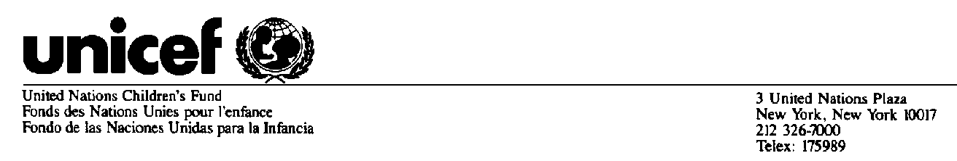
Believed to be the best available version at time of issuance

Statement by Unicef Executive Director Carol Bellamy
Welcoming US Government and Pharmaceutical Industry
Support for Universal Child Immunization

WASHINGTON, D.C., 2 March -- UNICEF Executive Director Carol Bellamy thanked U.S. President Bill Clinton for energizing the global effort to immunize all the world's children. She said Clinton's leadership in bringing together key representatives of the public and private sectors to today's White House meeting on the President's "Millennium Initiative" is precisely what is needed to begin to save the lives of nearly three million children who still die each year of vaccine-preventable illnesses.

Bellamy also expressed gratitude to the pharmaceuticals industry for its announcement today committing funds for research and development into new vaccines that will particularly benefit the poorest countries. Bellamy recognized certain individual pharmaceutical companies which announced donations of vaccines for use in the developing world. The UNICEF chief said the donations represent a good-faith commitment by the industry to actively support the work of the newly formed Global Alliance for Vaccines and Immunization (GAVI) and on-going efforts to improve children's health and quality of life.

However, Bellamy noted that the corporate donations -- important as they are -- represent only a tiny fraction of the resources required to achieve GAVI's mandate. She cautioned about the need to remain focused on the enormity of the challenges that remain in
addressing the three main obstacles to achieving the goal of universal immunization:

- the 30 million children born every year in poor countries who are still not receiving the 'basic six' immunizations;

- the growing disparity in the number of vaccines available to children in industrialized and developing countries; and

- the lack of investment in vaccine research and development for diseases that are prevalent in poorer countries, particularly HIV/AIDS, malaria and tuberculosis.

Bellamy reiterated UNICEF's absolute commitment to universal child immunization and the organisation's interest in working in partnership with the pharmaceuticals industry to obtain the very lowest sustainable vaccine prices for the poorest countries. Bellamy said UNICEF is eager to establish long-term framework agreements with vaccine manufacturers that are open and transparent.

UNICEF is a founding member of GAVI and, within the partnership, will especially focus on practical and on-the-ground delivery of immunisation services.

Today, UNICEF is the world's largest purchaser of vaccines for developing countries and spends over $100 million annually on vaccines and safe injection equipment. During the last five years, UNICEF has purchased some 1.2 billion doses of basic vaccines. In 2000 alone, the organisation plans to procure two billion doses of vaccines, including 1.4 billion doses of oral polio vaccine to support the goal of eradicating polio by the end of the year.

***

For further information, please contact:

Liza Barrie, UNICEF Division of Communication, 917-415-2489
Stacey Harris, UNICEF Division of Communication, New York, 212-922-2658

